**1)** Suppose you have a Piggie Bank with an initial amount of $50 and you have to add some more amount to it. Create a class 'AddAmount' with a data member named 'amount' with an initial value of $50. Now make two other derived class as follows:

Base class - no amount will be added to the Piggie Bank

Derived class - having a parameter which is the amount that will be added to the Piggie Bank Create an object of the 'AddAmount' class and display the final amount in the Piggie Bank.

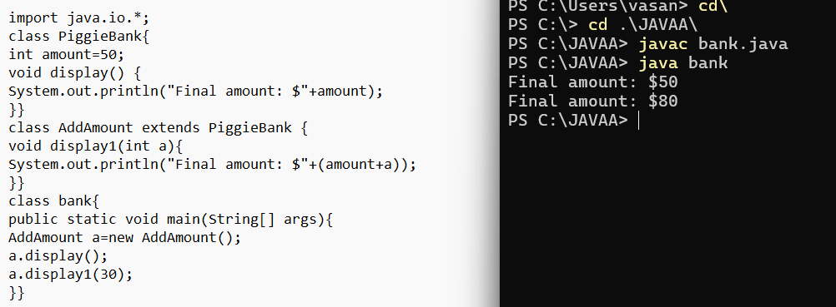

**2)**Write a Java program to demonstrate the multilevel inheritance by creating a class cuboid that extends class rectangle, class shape. It calculates area and volume.

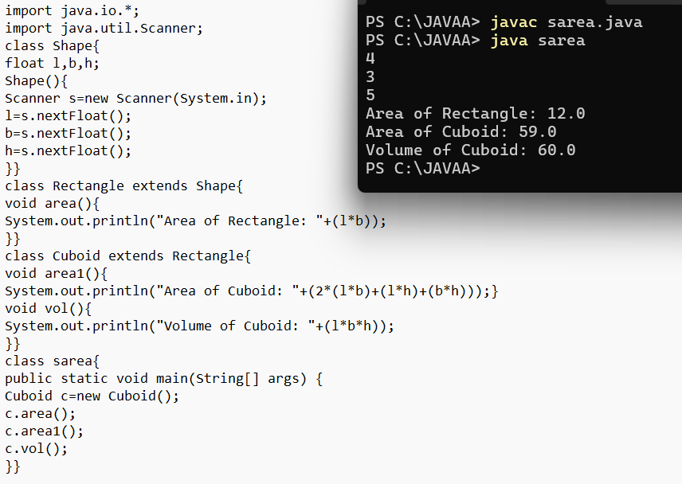

**3)**Write a program to calculate the bonus of the employees. The class master derives the information from both admin and from account classes which derives information from the class person. Create base and all derived classes having same member functions and parameters called getdata, display data and bonus.

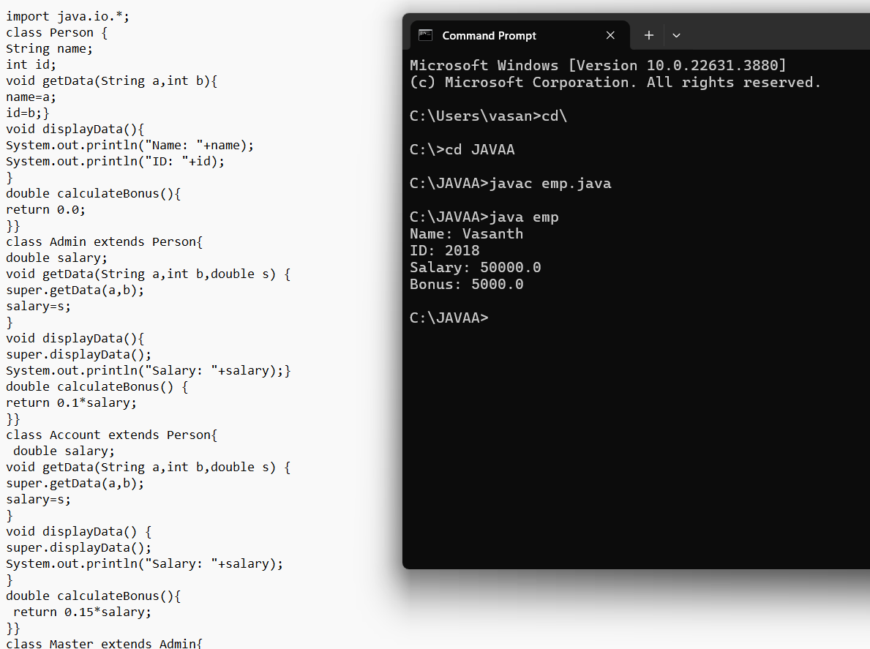

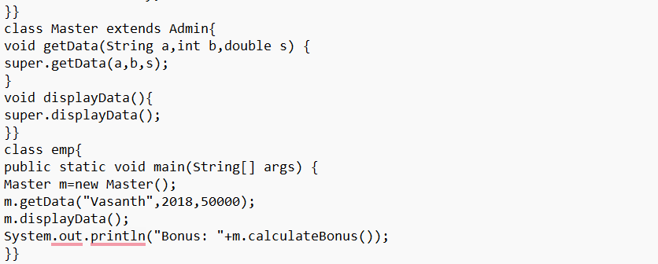

**4)** A paper consists of 4 authors, but one author didn’t do any work but he wants to put his name in this paper. But others are not interested at the same time they want to add another author as a 5th author. How to identify the Not worked for paper. Write a Java code for the above scenario.

